

A Report on

**Scholarship Management**

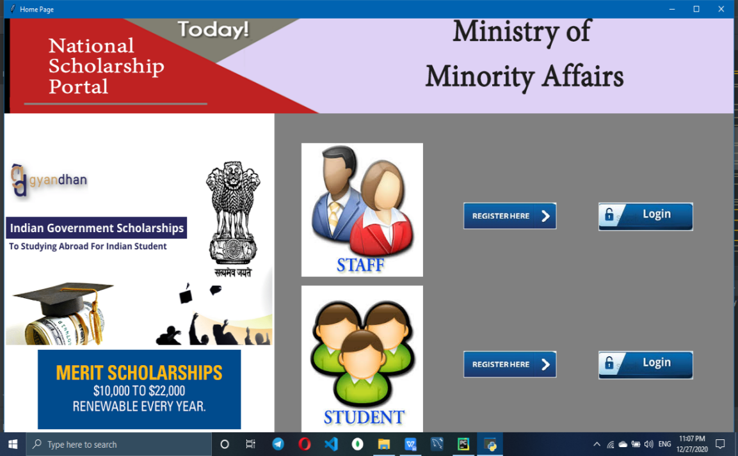

Submitted By :- Prashant Gupta.

Submitted To :- Aishwarya Saxena.

College :-Technocrats Institute of Technology, Bhopal.

**Index**

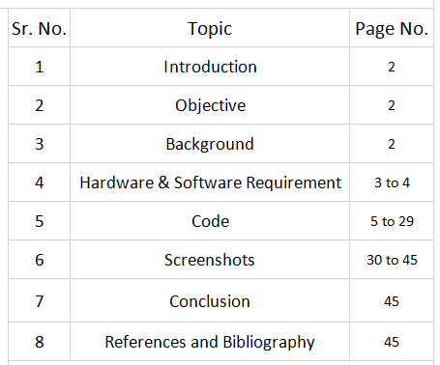

**Scholarship Management**

**Introduction:**

This report aims to present the overall functioning and operations of the online post matric scholarship management system in Andhra Pradesh, its impact and the challenges met so far. It aims to contribute towards the programme’s replication in order to strengthen public service delivery in this arena across the country.Students can register and login after successful login they can apply for the scholarship and staff can see status of all students by login in staff page.

**Objective:**

To develop an automatic & transparent scholarship and fee reimbursement system

for minority students in the state of Madhya Pradesh. Through the creation of an

efficient system, the hope is to contribute in a sustainable manner towards the

upliftment of the minority community.

**Background:**

The Government of Madhya Pradesh provides post matric and pre-matric scholarships for students from minority communities suffering from economic, educational and social backwardness. The merit-cum means scholarship was introduced for students of technical and professional courses at undergraduate and postgraduate level. The students of Class 11 to PhD level (including vocational and technical courses) and Class 1 to Class 10 are reached through the post-matric and pre-matric scholarships respectively. These scholarships are meant to enhance the educational opportunities for minority communities and contribute towards their empowerment in a sustainable manner.

**Hardware Requirement & Software Requirement**

**Hardware Requirement:**

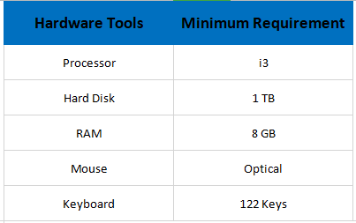

**Software Requirement:**

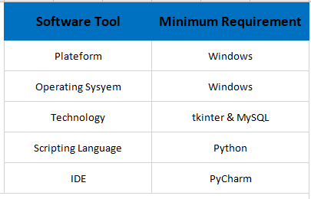

**Coding:**

**Libraries:**

ImageTk for including images to the window and frames from PIL module.

messagebox, mysql.connector, ttk are included.

**Homepage Code:**

from tkinter import *

from PIL import ImageTk

from tkinter import ttk, messagebox

import mysql.connector

class Mainpage:

def __init__(self,root):

self.root=root

self.root.title("Home Page")

self.root.geometry("1350x700+0+0")

# Top Image

self.top = ImageTk.PhotoImage(file="images/log.gif")

left = Label(self.root, image=self.top, bg="white").place(x=0, y=0, width=1350, height=160)

#Top left

self.top_left = ImageTk.PhotoImage(file="images/content_scholarships.png")

left = Label(self.root, image=self.top_left, bg="white").place(x=0, y=160, width=500, height=500)

self.bottom_left = ImageTk.PhotoImage(file="images/lll.png")

left = Label(self.root, image=self.bottom_left, bg="white").place(x=0, y=550, width=500, height=150)

# Login Frame

frame1 = Frame(self.root, bg="gray")

frame1.place(x=500, y=160, width=1000, height=800)

self.frame_left = ImageTk.PhotoImage(file="images/staff first.jpg")

left = Label(frame1, image=self.frame_left, bg="white").place(x=50, y=50, width=225, height=225)

self.frame_right = ImageTk.PhotoImage(file="images/sssss.jpg")

left = Label(frame1, image=self.frame_right, bg="white").place(x=50, y=290, width=225, height=255)

self.btn_staff = ImageTk.PhotoImage(file="images/pppp.jpg")

btn_register = Button(frame1, image=self.btn_staff, bd=0, cursor="hand2", command=self.register_window).place(x=350,

y=150)

# login button

self.btn_staffs = ImageTk.PhotoImage(file="images/llllll.jpg")

btn_login = Button(frame1, image=self.btn_staffs, bd=0, cursor="hand2", command=self.login_window).place(x=600,

y=150)

self.btn_student = ImageTk.PhotoImage(file="images/pppp.jpg")

btn_register = Button(frame1, image=self.btn_student, bd=0, cursor="hand2", command=self.register_windows).place(

x=350,

y=400)

# login button

self.btn_students = ImageTk.PhotoImage(file="images/llllll.jpg")

btn_login = Button(frame1, image=self.btn_students, bd=0, cursor="hand2", command=self.login_windows).place(x=600,

y=400)

def login_window(self):

self.root.destroy()

import staff_login

def register_window(self):

self.root.destroy()

import staff_registration

def login_windows(self):

self.root.destroy()

import staff_login

def register_windows(self):

self.root.destroy()

import student_registration

win = Tk()

obj = Mainpage(win)

win.mainloop()

**Staff Login Code:**

from tkinter import *

from PIL import ImageTk

from tkinter import ttk, messagebox

import mysql.connector

class Login:

def __init__(self,root):

self.root = root

self.root.title("Staff Login Window")

self.root.geometry("1350x700+0+0")

# LEFT Image

self.left = ImageTk.PhotoImage(file="images/logi.jpg")

bg = Label(self.root, image=self.left).place(x=0, y=160, width=600, height=600)

# Top Image

self.top = ImageTk.PhotoImage(file="images/log.gif")

left = Label(self.root, image=self.top, bg="gray").place(x=0, y=0, width=1350, height=160)

# Login Frame

frame1 = Frame(self.root, bg="red")

frame1.place(x=500, y=160, width=1000, height=800)

title = Label(frame1, text="STAFF LOGIN ", font=("times in roman", 20, "bold"), bg="red", fg="black").place(

x=50, y=30,width=800)

username = Label(frame1, text="Username", font=("times in roman", 15, "bold"), bg="red", fg="black").place(x=100,

y=100)

self.txt_username = Entry(frame1, font=("times in roman", 15), bg="lightgray")

self.txt_username.place(x=290, y=100, width=500)

password = Label(frame1, text="Password", font=("times in roman", 15, "bold"), bg="red", fg="black").place(

x=100, y=150)

self.txt_password = Entry(frame1, font=("times in roman", 15), bg="lightgray", show="*")

self.txt_password.place(x=290, y=150, width=500)

self.btn = Button(frame1, text="Login",command=self.login_data,cursor="hand2", font=("title in roman", 20,"bold"), bg="red", fg="black").place(x=290,y=350,width=200)

self.btn_newregistration = Button(frame1,cursor="hand2",command=self.register_window ,text="New Registration ?", font=("title in roman", 20, "bold"), bg="red", fg="black").place(x=510,

y=350,

width=280)

question = Label(frame1, text="Security Question", font=("times in roman", 15, "bold"), bg="red",

fg="black").place(x=100, y=200)

self.cmb_quests = ttk.Combobox(frame1, font=("times in roman", 13), state="readonly", justify=CENTER)

self.cmb_quests["values"] = ("Select", "Your First Pet Name ?", "Your Birth Place ?", "Your Best Friend Name ?")

self.cmb_quests.place(x=290, y=200, width=500)

self.cmb_quests.current(0)

answers = Label(frame1, text="Answer", font=("times in roman", 15, "bold"), bg="red", fg="black").place(x=100,

y=250)

self.txt_answers = Entry(frame1, font=("times in roman", 15), bg="lightgray")

self.txt_answers.place(x=290, y=250, width=500)

# home button

self.btn_imgss = ImageTk.PhotoImage(file="images/home.jpg")

btn_login = Button(root, image=self.btn_imgss, bd=0, cursor="hand2", command=self.home_window).place(x=1220,y=50)

def register_window(self):

self.root.destroy()

import staff_registration

def home_window(self):

self.root.destroy()

import Mainpage

def login_data(self):

if self.txt_username.get()=="" or self.txt_password.get()=="" or self.cmb_quests.get()=="" or self.txt_answers.get()=="":

messagebox.showerror("Error Occured", "All fields are required",parent=self.root)

else:

try:

db = mysql.connector.connect(

host="localhost",

user="root",

password="12345",

database="informations"

)

cur = db.cursor()

s = "SELECT * FROM details WHERE Email=%s AND Passwords=%s "

b1 = (self.txt_username.get(), self.txt_password.get())

cur.execute(s, b1)

row = cur.fetchone()

if row ==None:

messagebox.showerror("Error Occured", "Invalid Username or Password", parent=self.root)

else:

messagebox.showinfo("Congratulations", "Login Successful, click ok to see details And Application of Applied student", parent=self.root)

self.root.destroy()

import staff_details

cur.close()

except Exception as es:

messagebox.showerror("Error", f"Error due to;- {str(es)}", parent=self.root)

win = Tk()

obj=Login(win)

win.mainloop()

**Staff registration Code:**

from tkinter import *

from PIL import ImageTk

from tkinter import ttk, messagebox

import mysql.connector

class Register:

def __init__(self, root):

self.root = root

self.root.title("Staff Registration Window")

self.root.geometry("1350x700+0+0")

# BG Image

self.bg = ImageTk.PhotoImage(file="images/bg.jpg")

bg = Label(self.root, image=self.bg).place(x=0, y=0, relwidth=1, relheight=1)

# LEFT Image

self.left = ImageTk.PhotoImage(file="images/side.png.png")

left = Label(self.root, image=self.left,bg="blue").place(x=80, y=100, width=400, height=500)

# Register Frame

frame1 = Frame(self.root, bg="white")

frame1.place(x=480, y=100, width=700, height=500)

title = Label(frame1, text="STAFF REGISTRATION", font=("times in roman", 20, "bold"),

bg="white", fg="green").place(x=50, y=30)

f_name = Label(frame1, text="Full Name", font=("times in roman", 15, "bold"), bg="white",

fg="gray").place(x=50, y=100)

self.txt_f_name = Entry(frame1, font=("times in roman", 15), bg="lightgray")

self.txt_f_name.place(x=50, y=130, width=250)

gender = Label(frame1, text="Select Your Gender", font=("times in roman", 15, "bold"), bg="white",

fg="gray").place(x=370, y=100)

self.cmb_questss= ttk.Combobox(frame1, font=("times in roman", 13), state="readonly", justify=CENTER)

self.cmb_questss["values"] = ("Select", "Male", "Female", "Trans Gender", "Other")

self.cmb_questss.place(x=370, y=130, width=250)

self.cmb_questss.current(0)

#---------------------------------Row 2

contact = Label(frame1, text="Contact No.", font=("times in roman", 15, "bold"), bg="white", fg="gray").place(x=50, y=170)

self.txt_contact = Entry(frame1, font=("times in roman", 15), bg="lightgray")

self.txt_contact.place(x=50, y=200, width=250)

email = Label(frame1, text="Email", font=("times in roman", 15, "bold"), bg="white", fg="gray").place(x=370, y=170)

self.txt_email = Entry(frame1, font=("times in roman", 15), bg="lightgray")

self.txt_email.place(x=370, y=200, width=250)

# ---------------------------------Row 3

question = Label(frame1, text="Choose Your Category", font=("times in roman", 15, "bold"), bg="white", fg="gray").place(x=50, y=240)

self.cmb_quest = ttk.Combobox(frame1, font=("times in roman", 13),state="readonly", justify=CENTER)

self.cmb_quest["values"]=("Select","ST","SC","OBC","GEN","Other")

self.cmb_quest.place(x=50, y=270, width=250)

self.cmb_quest.current(0)

answer = Label(frame1, text="Age", font=("times in roman", 15, "bold"), bg="white", fg="gray").place(x=370, y=240)

self.txt_answer = Entry(frame1, font=("times in roman", 15), bg="lightgray")

self.txt_answer.place(x=370, y=270, width=250)

#------------------row 4

password = Label(frame1, text="Password", font=("times in roman", 15, "bold"), bg="white", fg="gray").place(x=50, y=310)

self.txt_password = Entry(frame1, font=("times in roman", 15), bg="lightgray",show="*")

self.txt_password.place(x=50, y=340, width=250)

c_password = Label(frame1, text="Conform Password", font=("times in roman", 15, "bold"), bg="white", fg="gray").place(x=370,y=310)

self.txt_c_password = Entry(frame1, font=("times in roman", 15), bg="lightgray",show="*")

self.txt_c_password.place(x=370, y=340, width=250)

#------------row 5 checkbox terms

self.var_chk = IntVar()

check = Checkbutton(frame1, text='I Agree The Terms and Conditions',variable=self.var_chk, onvalue=1, offvalue=0,bg="white",font=('times in roman',12)).place(x=50,y=380)

#register button

self.btn_img = ImageTk.PhotoImage(file="images/register.png")

btn_register = Button(frame1,image=self.btn_img, bd=0, cursor="hand2",command=self.register_data).place(x=50, y=420)

# login button

self.btn_imgs = ImageTk.PhotoImage(file="images/llllll.jpg")

btn_login = Button(self.root, image=self.btn_imgs, bd=0, cursor="hand2",command=self.login_window).place(x=210, y=550)

#home button

self.btn_imgss = ImageTk.PhotoImage(file="images/home.jpg")

btn_login = Button(frame1, image=self.btn_imgss, bd=0, cursor="hand2", command=self.home_window).place(x=600,

y=400)

def login_window(self):

self.root.destroy()

import staff_login

def home_window(self):

self.root.destroy()

import Mainpage

def register_data(self):

if self.txt_f_name.get() == "" or self.txt_email.get() == "" or self.cmb_quest.get() == "Select" or self.txt_answer.get() == "" or self.txt_contact.get() == "":

messagebox.showerror("Error","All Fields are Required", parent=self.root)

elif self.txt_password.get() != self.txt_c_password.get():

messagebox.showerror("Error", "Password and Conform Password should be same", parent=self.root)

elif self.var_chk.get() == 0:

messagebox.showerror("Error", "Agree with our terms and conditions", parent=self.root)

else:

try:

db = mysql.connector.connect(

host="localhost",

user="root",

password="12345",

database="informations"

)

cur = db.cursor()

s = "INSERT INTO details(Full_Name,Gender,Contact_no,Email,Cast,Age,Passwords) VALUES (%s, %s, %s, %s,%s,%s,%s)"

b1 = (self.txt_f_name.get(),

self.cmb_questss.get(),

self.txt_contact.get(),

self.txt_email.get(),

self.cmb_quest.get(),

self.txt_answer.get(),

self.txt_password.get());

cur.execute(s, b1)

db.commit();

db.close();

messagebox.showinfo("Success", "Registered Successfully", parent=self.root)

except Exception as es:

messagebox.showerror("Error", f"Error due to;- {str(es)}", parent=self.root)

win = Tk()

obj = Register(win)

win.mainloop()

**Staff view student application data Code:**

from tkinter import *

from PIL import ImageTk

from tkinter import ttk, messagebox

import mysql.connector

class Mainpage:

def __init__(self,root):

self.root=root

self.root.title("Student Basic details for staff ")

self.root.geometry("1350x800")

# home button

self.btn_imgss = ImageTk.PhotoImage(file="images/home.jpg")

btn_login = Button(root, image=self.btn_imgss, bd=0, cursor="hand2", command=self.home_window).place(x=600,

y=400)

self.top = ImageTk.PhotoImage(file="images/log.gif")

left = Label(self.root, image=self.top, bg="gray").place(x=0, y=500, width=1350, height=160)

try:

db = mysql.connector.connect(

host="localhost",

user="root",

password="12345",

database="informations"

)

cur = db.cursor()

cur.execute("SELECT * FROM pet limit 0,100")

i = 0

for pet in cur:

for j in range(len(pet)):

e = Entry(root, width=10)

e.grid(row=i, column=j, sticky="w")

e.insert(END, pet[j])

i = i + 1

print()

s = cur.execute("SELECT COUNT(mobile_no) FROM pet")

messagebox.showinfo("Success", "Scholarship Awarded to all student and details of student are mentioned above", parent=self.root)

except Exception as es:

messagebox.showerror("Error", f"Error due to;- {str(es)}", parent=self.root)

def home_window(self):

self.root.destroy()

import Mainpage

win = Tk()

obj=Mainpage(win)

win.mainloop()

**Student registration Code:**

from tkinter import *

from PIL import ImageTk

from tkinter import ttk, messagebox

import mysql.connector

class Register:

def __init__(self, root):

self.root = root

self.root.title("STUDENT Registration Window")

self.root.geometry("1350x700+0+0")

# BG Image

self.bg = ImageTk.PhotoImage(file="images/bg.jpg")

bg = Label(self.root, image=self.bg).place(x=0, y=0, relwidth=1, relheight=1)

# LEFT Image

self.left = ImageTk.PhotoImage(file="images/side.png.png")

left = Label(self.root, image=self.left,bg="blue").place(x=80, y=100, width=400, height=500)

# Register Frame

frame1 = Frame(self.root, bg="white")

frame1.place(x=480, y=100, width=700, height=500)

title = Label(frame1, text="STUDENT REGISTRATION", font=("times in roman", 20, "bold"),

bg="white", fg="green").place(x=50, y=30)

f_name = Label(frame1, text="Full Name", font=("times in roman", 15, "bold"), bg="white",

fg="gray").place(x=50, y=100)

self.txt_f_name = Entry(frame1, font=("times in roman", 15), bg="lightgray")

self.txt_f_name.place(x=50, y=130, width=250)

gender = Label(frame1, text="Select Your Gender", font=("times in roman", 15, "bold"), bg="white",

fg="gray").place(x=370, y=100)

self.cmb_questss= ttk.Combobox(frame1, font=("times in roman", 13), state="readonly", justify=CENTER)

self.cmb_questss["values"] = ("Select", "Male", "Female", "Trans Gender", "Other")

self.cmb_questss.place(x=370, y=130, width=250)

self.cmb_questss.current(0)

#---------------------------------Row 2

contact = Label(frame1, text="Contact No.", font=("times in roman", 15, "bold"), bg="white", fg="gray").place(x=50, y=170)

self.txt_contact = Entry(frame1, font=("times in roman", 15), bg="lightgray")

self.txt_contact.place(x=50, y=200, width=250)

email = Label(frame1, text="Email", font=("times in roman", 15, "bold"), bg="white", fg="gray").place(x=370, y=170)

self.txt_email = Entry(frame1, font=("times in roman", 15), bg="lightgray")

self.txt_email.place(x=370, y=200, width=250)

# ---------------------------------Row 3

question = Label(frame1, text="Choose Your Category", font=("times in roman", 15, "bold"), bg="white", fg="gray").place(x=50, y=240)

self.cmb_quest = ttk.Combobox(frame1, font=("times in roman", 13),state="readonly", justify=CENTER)

self.cmb_quest["values"]=("Select","ST","SC","OBC","GEN","Other")

self.cmb_quest.place(x=50, y=270, width=250)

self.cmb_quest.current(0)

answer = Label(frame1, text="Age", font=("times in roman", 15, "bold"), bg="white", fg="gray").place(x=370, y=240)

self.txt_answer = Entry(frame1, font=("times in roman", 15), bg="lightgray")

self.txt_answer.place(x=370, y=270, width=250)

#------------------row 4

password = Label(frame1, text="Password", font=("times in roman", 15, "bold"), bg="white", fg="gray").place(x=50, y=310)

self.txt_password = Entry(frame1, font=("times in roman", 15), bg="lightgray",show="*")

self.txt_password.place(x=50, y=340, width=250)

c_password = Label(frame1, text="Conform Password", font=("times in roman", 15, "bold"), bg="white", fg="gray").place(x=370,y=310)

self.txt_c_password = Entry(frame1, font=("times in roman", 15), bg="lightgray",show="*")

self.txt_c_password.place(x=370, y=340, width=250)

#------------row 5 checkbox terms

self.var_chk = IntVar()

check = Checkbutton(frame1, text='I Agree The Terms and Conditions',variable=self.var_chk, onvalue=1, offvalue=0,bg="white",font=('times in roman',12)).place(x=50,y=380)

#register button

self.btn_img = ImageTk.PhotoImage(file="images/register.png")

btn_register = Button(frame1,image=self.btn_img, bd=0, cursor="hand2",command=self.register_data).place(x=50, y=420)

# login button

self.btn_imgs = ImageTk.PhotoImage(file="images/llllll.jpg")

btn_login = Button(self.root, image=self.btn_imgs, bd=0, cursor="hand2",command=self.login_window).place(x=210, y=550)

#home button

self.btn_imgss = ImageTk.PhotoImage(file="images/home.jpg")

btn_login = Button(frame1, image=self.btn_imgss, bd=0, cursor="hand2", command=self.home_window).place(x=600,

y=400)

def login_window(self):

self.root.destroy()

import student_login

def home_window(self):

self.root.destroy()

import Mainpage

def register_data(self):

if self.txt_f_name.get() == "" or self.txt_email.get() == "" or self.cmb_quest.get() == "Select" or self.txt_answer.get() == "" or self.txt_contact.get() == "":

messagebox.showerror("Error","All Fields are Required", parent=self.root)

elif self.txt_password.get() != self.txt_c_password.get():

messagebox.showerror("Error", "Password and Conform Password should be same", parent=self.root)

elif self.var_chk.get() == 0:

messagebox.showerror("Error", "Agree with our terms and conditions", parent=self.root)

else:

try:

db = mysql.connector.connect(

host="localhost",

user="root",

password="12345",

database="informations"

)

cur = db.cursor()

s = "INSERT INTO details(Full_Name,Gender,Contact_no,Email,Cast,Age,Passwords) VALUES (%s, %s, %s, %s,%s,%s,%s)"

b1 = (self.txt_f_name.get(),

self.cmb_questss.get(),

self.txt_contact.get(),

self.txt_email.get(),

self.cmb_quest.get(),

self.txt_answer.get(),

self.txt_password.get());

cur.execute(s, b1)

db.commit();

db.close();

messagebox.showinfo("Success", "Registered Successfully", parent=self.root)

except Exception as es:

messagebox.showerror("Error", f"Error due to;- {str(es)}", parent=self.root)

win = Tk()

obj = Register(win)

win.mainloop()

**Student Login Code:**

from tkinter import *

from PIL import ImageTk

from tkinter import ttk, messagebox

import mysql.connector

class Login:

def __init__(self,root):

self.root = root

self.root.title("Student Login Window")

self.root.geometry("1350x700+0+0")

# LEFT Image

self.left = ImageTk.PhotoImage(file="images/logi.jpg")

bg = Label(self.root, image=self.left).place(x=0, y=160, width=600, height=600)

# Top Image

self.top = ImageTk.PhotoImage(file="images/log.gif")

left = Label(self.root, image=self.top, bg="gray").place(x=0, y=0, width=1350, height=160)

# Login Frame

frame1 = Frame(self.root, bg="red")

frame1.place(x=500, y=160, width=1000, height=800)

title = Label(frame1, text="STUDENT LOGIN ", font=("times in roman", 20, "bold"), bg="red", fg="black").place(

x=50, y=30,width=800)

mobile = Label(frame1, text="Mobile No.", font=("times in roman", 15, "bold"), bg="red", fg="black").place(x=100,

y=100)

self.txt_mobile = Entry(frame1, font=("times in roman", 15), bg="lightgray")

self.txt_mobile.place(x=290, y=100, width=500)

password = Label(frame1, text="Password", font=("times in roman", 15, "bold"), bg="red", fg="black").place(

x=100, y=150)

self.txt_password = Entry(frame1, font=("times in roman", 15), bg="lightgray", show="*")

self.txt_password.place(x=290, y=150, width=500)

self.btn = Button(frame1, text="Login",command=self.login_data,cursor="hand2", font=("title in roman", 20,"bold"), bg="red", fg="black").place(x=290,y=350,width=200)

self.btn_newregistration = Button(frame1,cursor="hand2",command=self.register_window ,text="New Registration ?", font=("title in roman", 20, "bold"), bg="red", fg="black").place(x=510,

y=350,

width=280)

question = Label(frame1, text="Security Question", font=("times in roman", 15, "bold"), bg="red",

fg="black").place(x=100, y=200)

self.cmb_quests = ttk.Combobox(frame1, font=("times in roman", 13), state="readonly", justify=CENTER)

self.cmb_quests["values"] = ("Select", "Your First Pet Name ?", "Your Birth Place ?", "Your Best Friend Name ?")

self.cmb_quests.place(x=290, y=200, width=500)

self.cmb_quests.current(0)

answers = Label(frame1, text="Answer", font=("times in roman", 15, "bold"), bg="red", fg="black").place(x=100,

y=250)

self.txt_answers = Entry(frame1, font=("times in roman", 15), bg="lightgray")

self.txt_answers.place(x=290, y=250, width=500)

# home button

self.btn_imgss = ImageTk.PhotoImage(file="images/home.jpg")

btn_login = Button(frame1, image=self.btn_imgss, bd=0, cursor="hand2", command=self.home_window).place(x=690,

y=420)

def register_window(self):

self.root.destroy()

import student_registration

def home_window(self):

self.root.destroy()

import Mainpage

def login_data(self):

if self.txt_mobile.get()=="" or self.txt_password.get()=="" or self.cmb_quests.get()=="" or self.txt_answers.get()=="":

messagebox.showerror("Error Occured", "All fields are required",parent=self.root)

else:

try:

db = mysql.connector.connect(

host="localhost",

user="root",

password="12345",

database="informations"

)

cur = db.cursor()

s = "SELECT * FROM details WHERE Contact_no =%s AND Passwords=%s "

b1 = (self.txt_mobile.get(), self.txt_password.get())

cur.execute(s, b1)

row = cur.fetchone()

if row ==None:

messagebox.showerror("Error Occured", "Invalid Username or Password", parent=self.root)

else:

messagebox.showinfo("Congratulations", "Login Successful,Click ok to move further process", parent=self.root)

self.root.destroy()

import student_details

cur.close()

except Exception as es:

messagebox.showerror("Error", f"Error due to;- {str(es)}", parent=self.root)

win = Tk()

obj=Login(win)

win.mainloop()

**Student Application:**

from tkinter import *

from PIL import ImageTk

from tkinter import ttk, messagebox

import mysql.connector

class Mainpage:

def __init__(self,root):

self.root=root

self.root.title("Application Form for Student ")

self.root.geometry("1350x800")

# Top Image

self.top = ImageTk.PhotoImage(file="images/log.gif")

left = Label(self.root, image=self.top, bg="white").place(x=0, y=0, width=1350, height=160)

frame1 = Frame(self.root, bg="gray")

frame1.place(x=0, y=160, width=1400, height=1000)

frame2 = Frame(frame1, bg="red")

frame2.place(x=0, y=0, width=1400, height=40)

title = Label(frame2,text="Student Entry Details",font=("times in roman", 20, "bold"),

bg="red" ,fg="black").place(x=500,)

# -----------first row

f_name = Label(frame1, text="Full Name", font=("times in roman", 15, "bold"), bg="gray",

fg="black").place(x=50, y=50)

self.txt_f_name = Entry(frame1, font=("times in roman", 15), bg="lightgray")

self.txt_f_name.place(x=200, y=50, width=200)

Age = Label(frame1, text="Age in Years", font=("times in roman", 15, "bold"), bg="gray",

fg="black").place(x=450, y=50)

self.txt_Age = Entry(frame1, font=("times in roman", 15), bg="lightgray")

self.txt_Age.place(x=600, y=50, width=200)

#-----------2nd row

father_name = Label(frame1, text="Father's Name", font=("times in roman", 15, "bold"), bg="gray",

fg="black").place(x=50, y=80)

self.txt_father_name = Entry(frame1, font=("times in roman", 15), bg="lightgray")

self.txt_father_name.place(x=200, y=80, width=200)

mother_name = Label(frame1, text="Mother's Name", font=("times in roman", 15, "bold"), bg="gray",

fg="black").place(x=450, y=80)

self.txt_mother = Entry(frame1, font=("times in roman", 15), bg="lightgray")

self.txt_mother.place(x=600, y=80, width=200)

frame3 = Frame(frame1, bg="red")

frame3.place(x=0, y=115, width=1400, height=30)

mobile = Label(frame1, text="Mobile Number", font=("times in roman", 15, "bold"), bg="gray",

fg="black").place(x=850, y=50)

self.txt_mobile = Entry(frame1, font=("times in roman", 15), bg="lightgray")

self.txt_mobile.place(x=1020, y=50, width=200)

email = Label(frame1, text="Email", font=("times in roman", 15, "bold"), bg="gray",

fg="black").place(x=850, y=80)

self.txt_email = Entry(frame1, font=("times in roman", 15), bg="lightgray")

self.txt_email.place(x=1020, y=80, width=200)

title = Label(frame3,text="Course Details - Presently Studying",font=("times in roman", 15, "bold"),

bg="red" ,fg="black").place(x=500,height=25)

#--------------3rd row

address= Label(frame1, text="Address", font=("times in roman", 15, "bold"), bg="gray",

fg="black").place(x=50, y=150)

self.txt_address = Entry(frame1, font=("times in roman", 15), bg="lightgray")

self.txt_address.place(x=200, y=155, width=200)

pin = Label(frame1, text="Pin Code", font=("times in roman", 15, "bold"), bg="gray",

fg="black").place(x=450, y=155)

self.txt_pin= Entry(frame1, font=("times in roman", 15), bg="lightgray")

self.txt_pin.place(x=600, y=155, width=200)

#----------------4rt row

country = Label(frame1, text="Country", font=("times in roman", 15, "bold"), bg="gray",

fg="black").place(x=50, y=190)

self.cmb_Country = ttk.Combobox(frame1, font=("times in roman", 13), state="readonly", justify=CENTER)

self.cmb_Country["values"] = ("Select", "India", "London", "USA", "UK", "UAE", "Other")

self.cmb_Country.place(x=200, y=190, width=200)

self.cmb_Country.current(0)

Aadhar = Label(frame1, text="Aadhar Number", font=("times in roman", 15, "bold"), bg="gray",

fg="black").place(x=450, y=190)

self.txt_Aadhar = Entry(frame1, font=("times in roman", 15), bg="lightgray")

self.txt_Aadhar.place(x=600, y=190, width=200)

Domicile = Label(frame1, text="Domicile/UT", font=("times in roman", 15, "bold"), bg="gray",

fg="black").place(x=50, y=225)

self.cmb_Domicile = ttk.Combobox(frame1, font=("times in roman", 13), state="readonly", justify=CENTER)

self.cmb_Domicile["values"] = ("Select", "Madhya Pradesh", "Uttar Pradesh", "Assam", "Bihar", "Gujarat", "Other")

self.cmb_Domicile.place(x=200, y=225, width=200)

self.cmb_Domicile.current(0)

tution_fee = Label(frame1, text="Tution Fee", font=("times in roman", 15, "bold"), bg="gray",

fg="black").place(x=450, y=225)

self.txt_tution_fee = Entry(frame1, font=("times in roman", 15), bg="lightgray")

self.txt_tution_fee.place(x=600, y=225, width=200)

frame4 = Frame(frame1, bg="red")

frame4.place(x=0, y=260, width=1400, height=30)

title = Label(frame4, text="Qualification Examination Passes",

font=("times in roman", 15, "bold"),

bg="red", fg="black").place(x=500, height=25)

exam_passed = Label(frame1, text="Exam Passed", font=("times in roman", 15, "bold"), bg="gray",

fg="black").place(x=50, y=300)

self.cmb_exam_passed = ttk.Combobox(frame1, font=("times in roman", 13), state="readonly", justify=CENTER)

self.cmb_exam_passed["values"] = (

"Select", "SSLC/X", "HSC/+2/Vocational", "Diploma", "UG Degree", "PG Degree", "Other")

self.cmb_exam_passed.place(x=200, y=300, width=200)

self.cmb_exam_passed.current(0)

yop = Label(frame1, text="Passing Year", font=("times in roman", 15, "bold"), bg="gray",

fg="black").place(x=450, y=300)

self.txt_yop = Entry(frame1, font=("times in roman", 15), bg="lightgray")

self.txt_yop.place(x=600, y=300, width=200)

frame5 = Frame(frame1, bg="red")

frame5.place(x=0, y=340, width=1400, height=30)

title = Label(frame5, text="Bank Details",

font=("times in roman", 15, "bold"),

bg="red", fg="black").place(x=600, height=25)

institute_name = Label(frame1, text="Institute Name", font=("times in roman", 15, "bold"), bg="gray",

fg="black").place(x=850, y=155)

self.cmb_institute_name = ttk.Combobox(frame1, font=("times in roman", 13), state="readonly", justify=CENTER)

self.cmb_institute_name["values"] = (

"Select", "TIT Main", "TIT SCIENCE", "TIT ADVANCE", "TIT EXCELLENCE", "Other")

self.cmb_institute_name.place(x=1020, y=155, width=200)

self.cmb_institute_name.current(0)

course_name = Label(frame1, text="Course Name", font=("times in roman", 15, "bold"), bg="gray",

fg="black").place(x=850, y=190)

self.cmb_course_name = ttk.Combobox(frame1, font=("times in roman", 13), state="readonly", justify=CENTER)

self.cmb_course_name["values"] = (

"Select", "B.Tech", "M.Tech", "MBA", "MSc", "Other")

self.cmb_course_name.place(x=1020, y=190, width=200)

self.cmb_course_name.current(0)

roll = Label(frame1, text="Roll No", font=("times in roman", 15, "bold"), bg="gray",

fg="black").place(x=850, y=225)

self.txt_roll = Entry(frame1, font=("times in roman", 15), bg="lightgray")

self.txt_roll.place(x=1020, y=225, width=200)

Acc_No = Label(frame1, text="Account No", font=("times in roman", 15, "bold"), bg="gray",

fg="black").place(x=50, y=370)

self.txt_Acc_No = Entry(frame1, font=("times in roman", 15), bg="lightgray")

self.txt_Acc_No.place(x=200, y=375, width=200)

bank_name= Label(frame1, text="Bank Name", font=("times in roman", 15, "bold"), bg="gray",

fg="black").place(x=450, y=370)

self.cmb_bank_name = ttk.Combobox(frame1, font=("times in roman", 13), state="readonly", justify=CENTER)

self.cmb_bank_name["values"] = (

"Select", "SBI", "UBI", "Axis Bank", "Paytm Payment Bank","Airtel Payment Bank", "Other")

self.cmb_bank_name.place(x=600, y=375, width=200)

self.cmb_bank_name.current(0)

ifsc = Label(frame1, text="IFSC Code", font=("times in roman", 15, "bold"), bg="gray",

fg="black").place(x=850, y=370)

self.txt_ifsc = Entry(frame1, font=("times in roman", 15), bg="lightgray")

self.txt_ifsc.place(x=1020, y=370, width=200)

marks = Label(frame1, text="Marks in %", font=("times in roman", 15, "bold"), bg="gray",

fg="black").place(x=850, y=300)

self.txt_marks = Entry(frame1, font=("times in roman", 15), bg="lightgray")

self.txt_marks.place(x=1020, y=300, width=200)

cast = Label(frame1, text="Category", font=("times in roman", 15, "bold"), bg="gray",

fg="black").place(x=50, y=410)

self.txt_cast = ttk.Combobox(frame1, font=("times in roman", 13), state="readonly", justify=CENTER)

self.txt_cast["values"] = ("Select", "ST", "SC", "OBC", "GEN", "Other")

self.txt_cast.place(x=200, y=410, width=200)

self.txt_cast.current(0)

dob = Label(frame1, text="DOB(d/m/y)", font=("times in roman", 15, "bold"), bg="gray",

fg="black").place(x=450, y=410)

self.txt_dob = Entry(frame1, font=("times in roman", 13), bg="lightgray")

self.txt_dob.place(x=600, y=410, width=200)

# save & next button

self.btn_imgs = ImageTk.PhotoImage(file="images/save.png")

btn_register = Button(frame1, image=self.btn_imgs, bd=0, cursor="hand2", command=self.register_data).place(x=1220, y=420)

self.btn_imgss = ImageTk.PhotoImage(file="images/home de.jpg")

btn_register = Button(self.root, image=self.btn_imgss, bd=0, cursor="hand2", command=self.home_window).place(

x=1220, y=50)

def register_data(self):

if self.txt_f_name.get() == "" or self.txt_Age.get() == "" or self.txt_marks.get() == "Select" or self.txt_ifsc.get() == "" or self.cmb_bank_name.get() == "" or self.txt_Acc_No.get()=="" or self.txt_roll.get()=="" or self.txt_dob.get()=="" or self.txt_cast.get()=="" or self.cmb_course_name.get()=="" or self.cmb_institute_name.get()=="" or self.txt_yop.get()=="" or self.cmb_exam_passed.get()=="" or self.txt_tution_fee.get()=="" or self.cmb_Domicile.get()=="" or self.txt_pin.get()=="" or self.txt_address.get()=="" or self.txt_Aadhar.get()=="" or self.cmb_Country.get()=="" or self.txt_email.get()=="" or self.txt_mobile.get()=="" or self.txt_father_name.get()=="" or self.txt_mother.get()=="":

messagebox.showerror("Error", "All Fields are Required", parent=self.root)

elif self.txt_Age.get() < "18" and self.txt_Age.get() > "25" or self.txt_cast.get()=="GEN":

messagebox.showerror("Error", "You are not eligible for the scholarship due to age or cast", parent=self.root)

else:

try:

db = mysql.connector.connect(

host="localhost",

user="root",

password="12345",

database="informations"

)

cur = db.cursor()

s = "INSERT INTO pet (name,age,mobile_no,father_name,mother_name,email,address,pin,institute,country,aadhar,course,domicile,tution_fee,roll_no,exam_passed,passing_year,marks_in_percentage,account_no,bank_name,ifsc_code,cast,dob)VALUES (%s,%s,%s,%s,%s,%s,%s,%s,%s,%s,%s,%s,%s,%s,%s,%s,%s,%s,%s,%s,%s,%s,%s)";

b1 = ( self.txt_f_name.get() ,

self.txt_Age.get() ,

self.txt_mobile.get(),

self.txt_father_name.get(),

self.txt_mother.get(),

self.txt_email.get(),

self.txt_address.get(),

self.txt_pin.get(),

self.cmb_institute_name.get(),

self.cmb_Country.get(),

self.txt_Aadhar.get(),

self.cmb_course_name.get(),

self.cmb_Domicile.get(),

self.txt_tution_fee.get(),

self.txt_roll.get(),

self.cmb_exam_passed.get(),

self.txt_yop.get(),

self.txt_marks.get(),

self.txt_Acc_No.get(),

self.cmb_bank_name.get(),

self.txt_ifsc.get() ,

self.txt_cast.get(),

self.txt_dob.get(),

);

cur.execute(s, b1)

db.commit();

db.close();

messagebox.showwarning("Conformation","once data will be saved you can not modify it, Do you want to proceed , if yes then click ok to move next", parent=self.root)

messagebox.showinfo("Congratulations ", f"{self.txt_f_name.get()} Application Has been received , your amount of {self.txt_tution_fee.get()} rupees will be reflected to your account provided by you ", parent=self.root)

except Exception as es:

messagebox.showerror("Error", f"Error due to;- {str(es)}", parent=self.root)

def home_window(self):

self.root.destroy()

import Mainpage

win = Tk()

obj=Mainpage(win)

win.mainloop()

**Screenshots:**

**Home Page:**

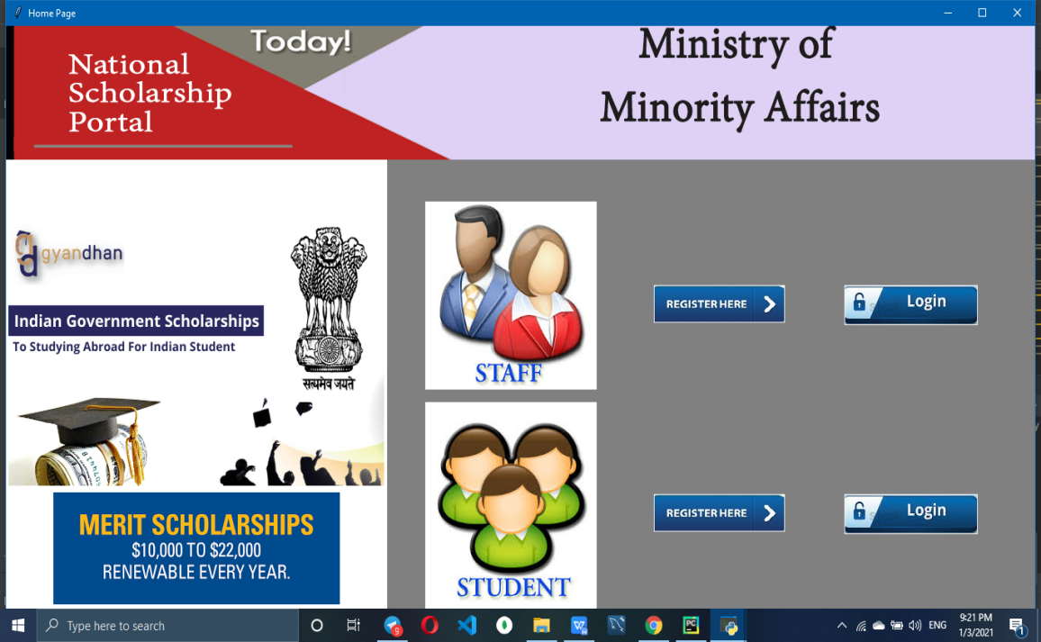

Click on “Registration Here” Button

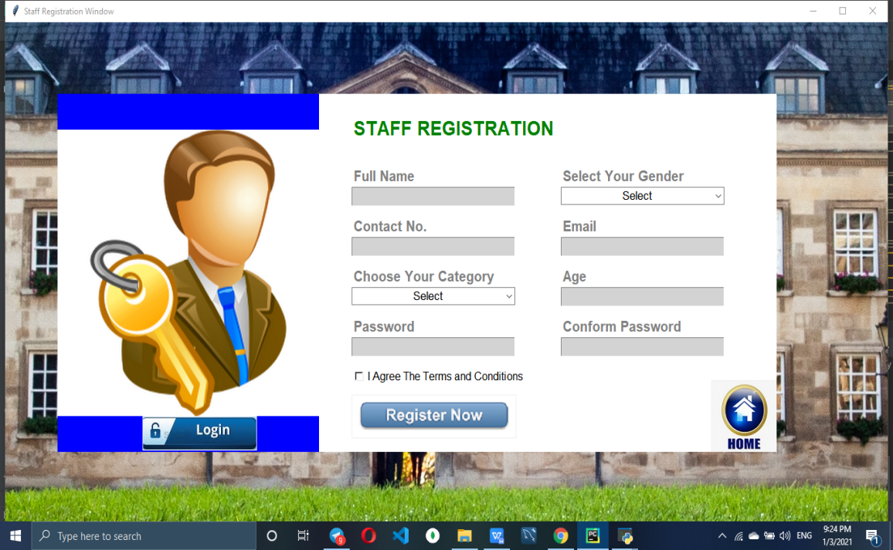

Click on “Register Now” we have to fill all column otherwise it will through error in messagebox shown below -

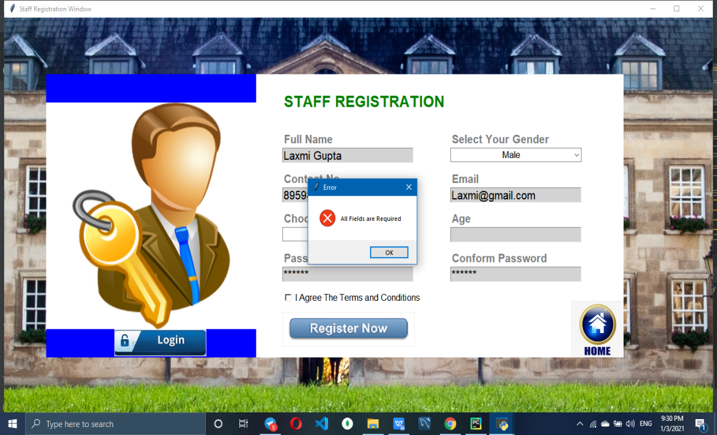

Click ok and enter all inputs. If we will not provide the same Password and Conform Password then it will through error in messagebox shown below -

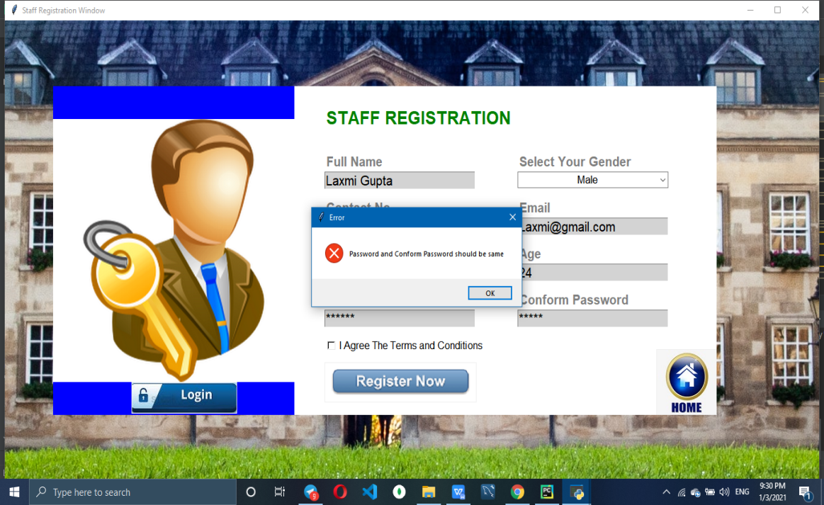

Enter correct password. If we will not agree with terms and conditions again messegebox will appear containing error shown below -

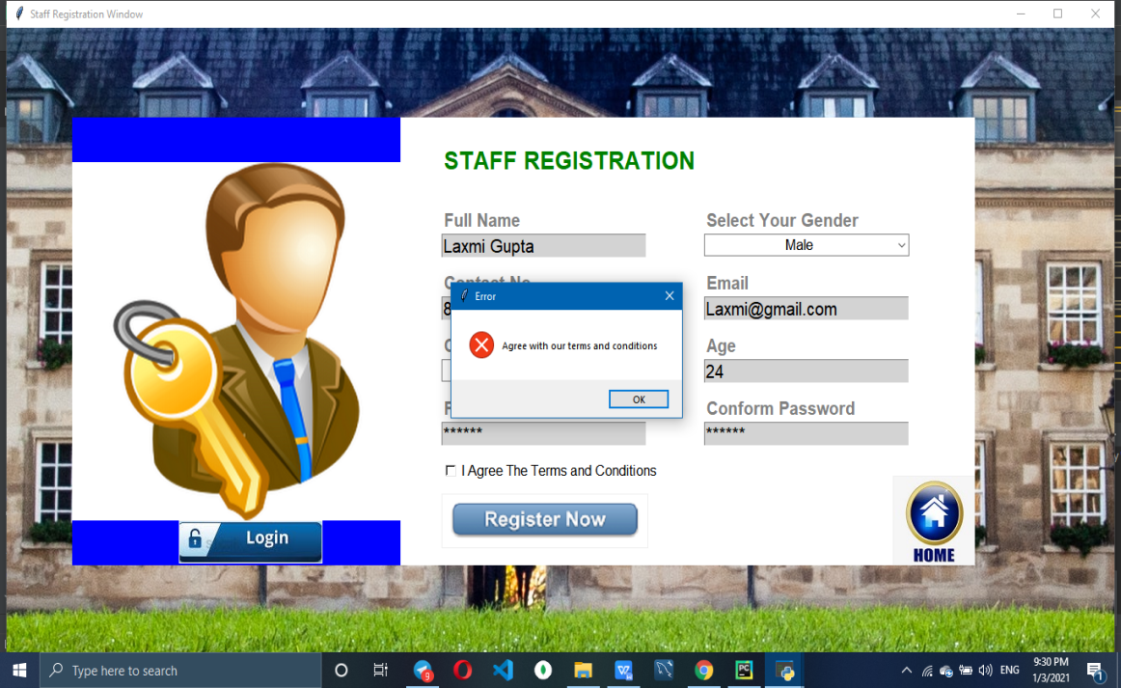

After agree with terms and conditions. A messege will appear like shown below-

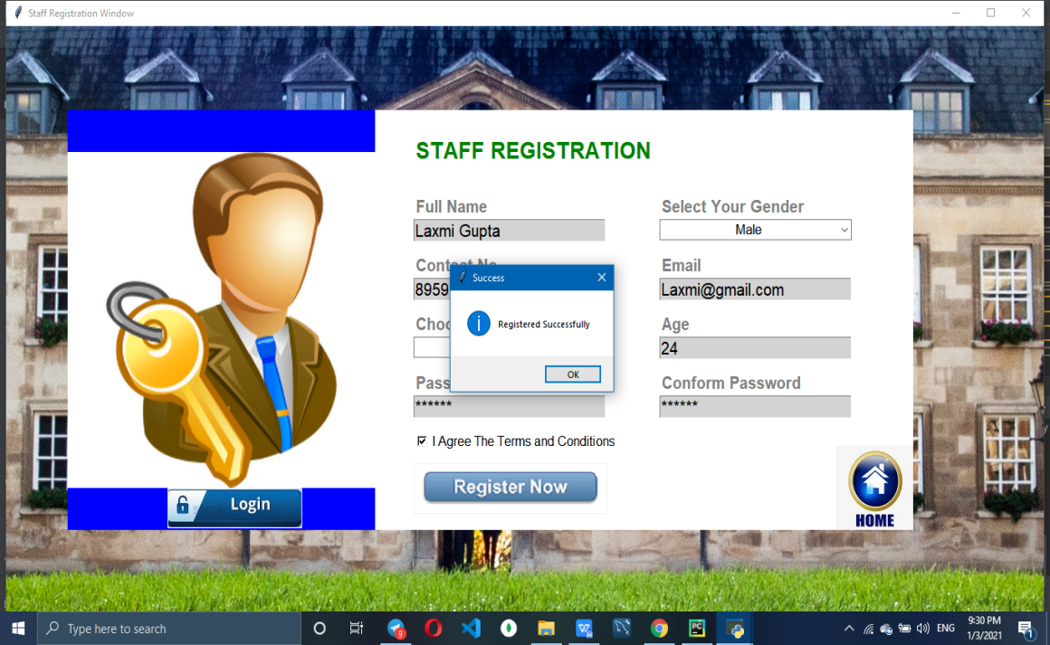

After Successfully Registration. The data of staff will stote in database “details” table shown below -

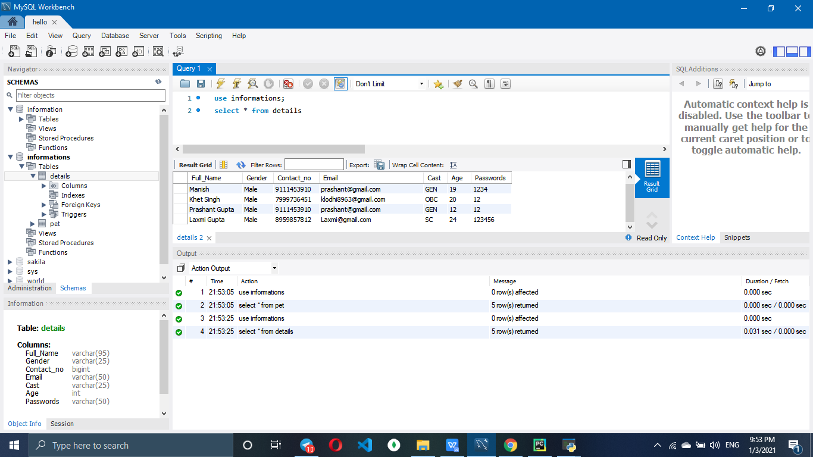

After Successfully Registration. Whether staff can login or go to home page by clicking home button or login button.

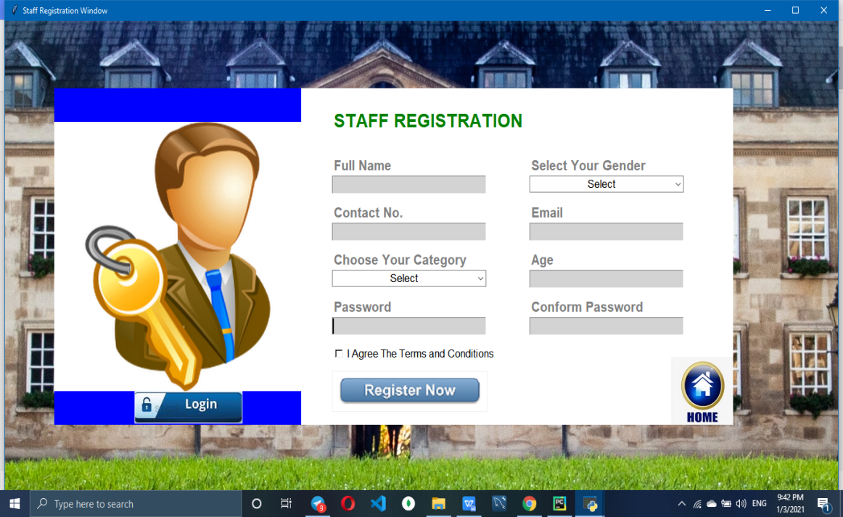

If staff will click on home button then he will redirected to home page. After landing on page staff also can login by home page and also can login by this page shown below -

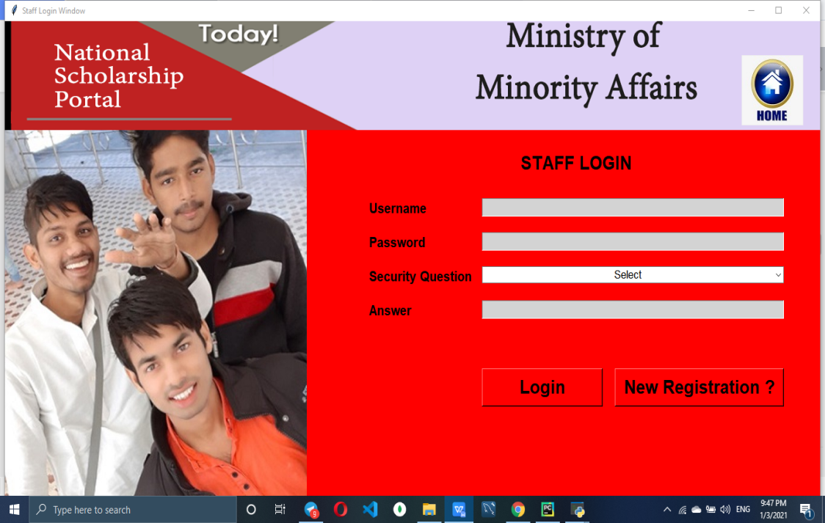

Click on login without entering data or login with mitchmacth credintial and it will give error shown below -

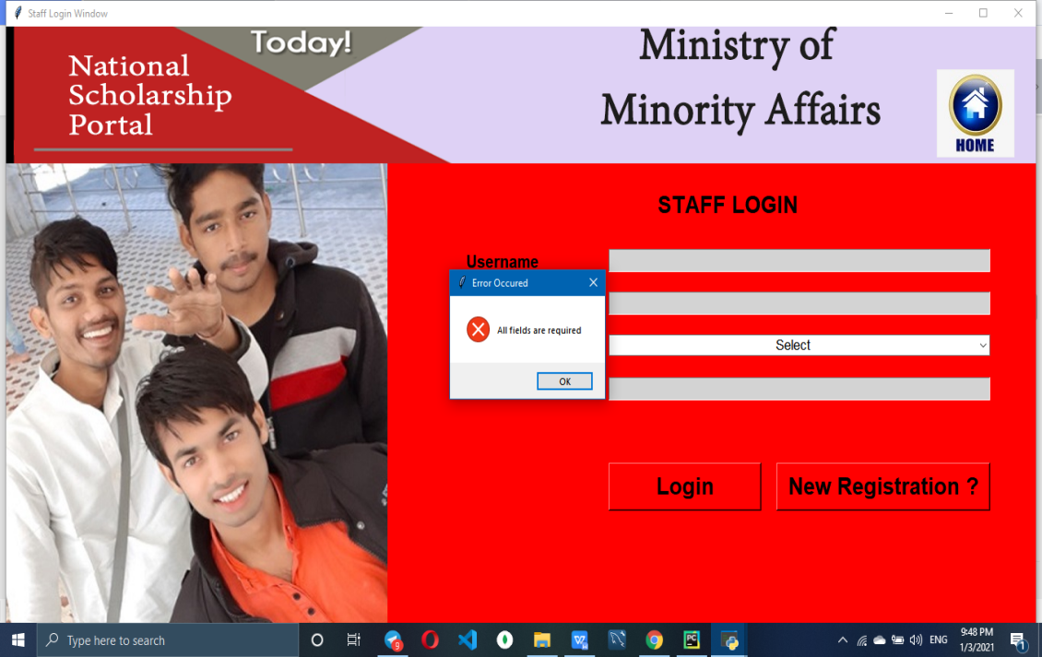

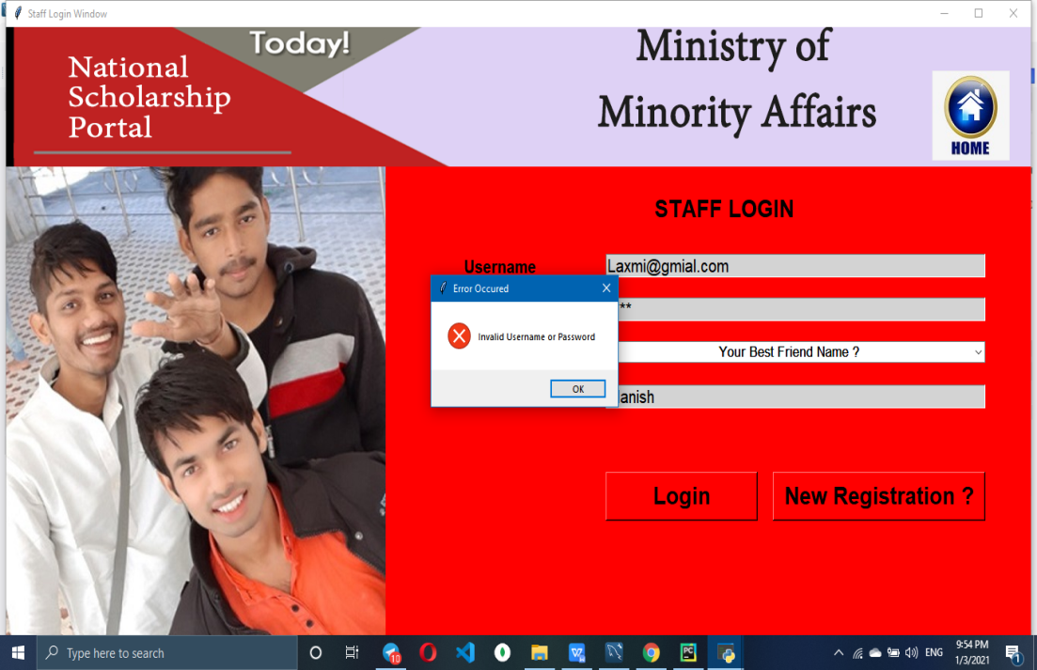

Now Enter Correct username and password. After login Staff can see all the application of student and also can go to homepage after clicking on gome button shown below -

-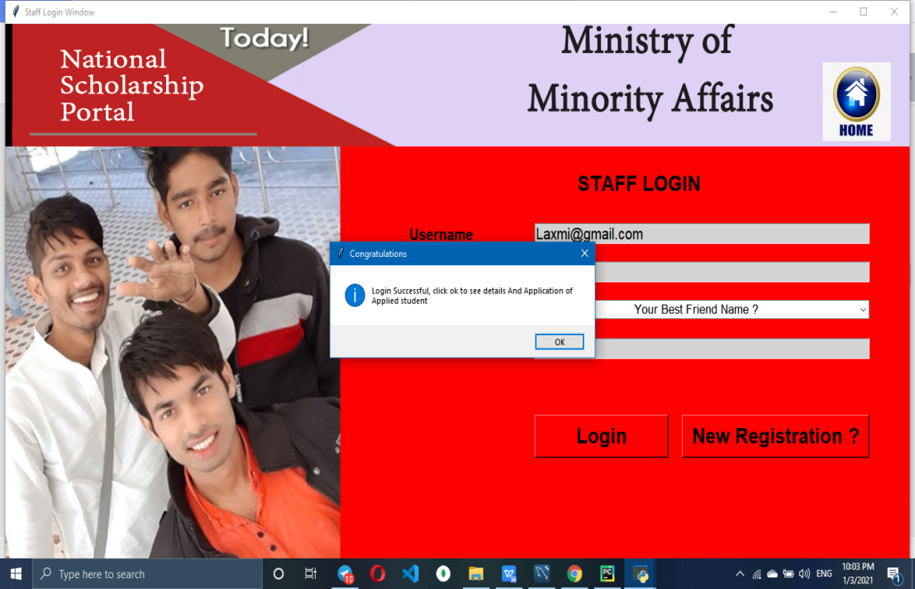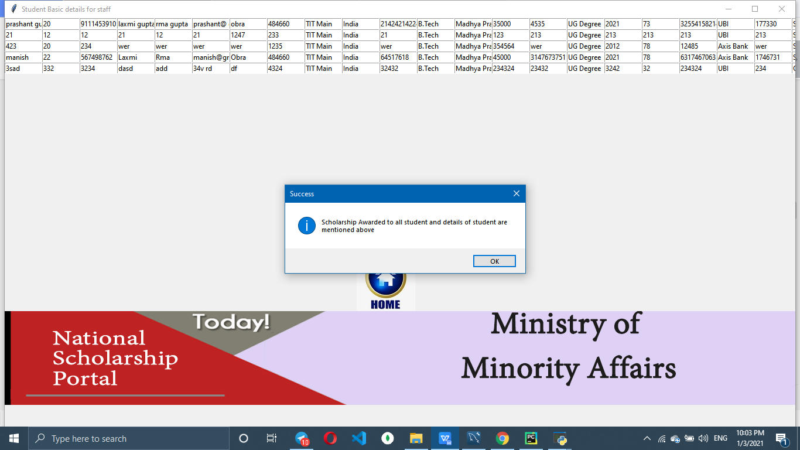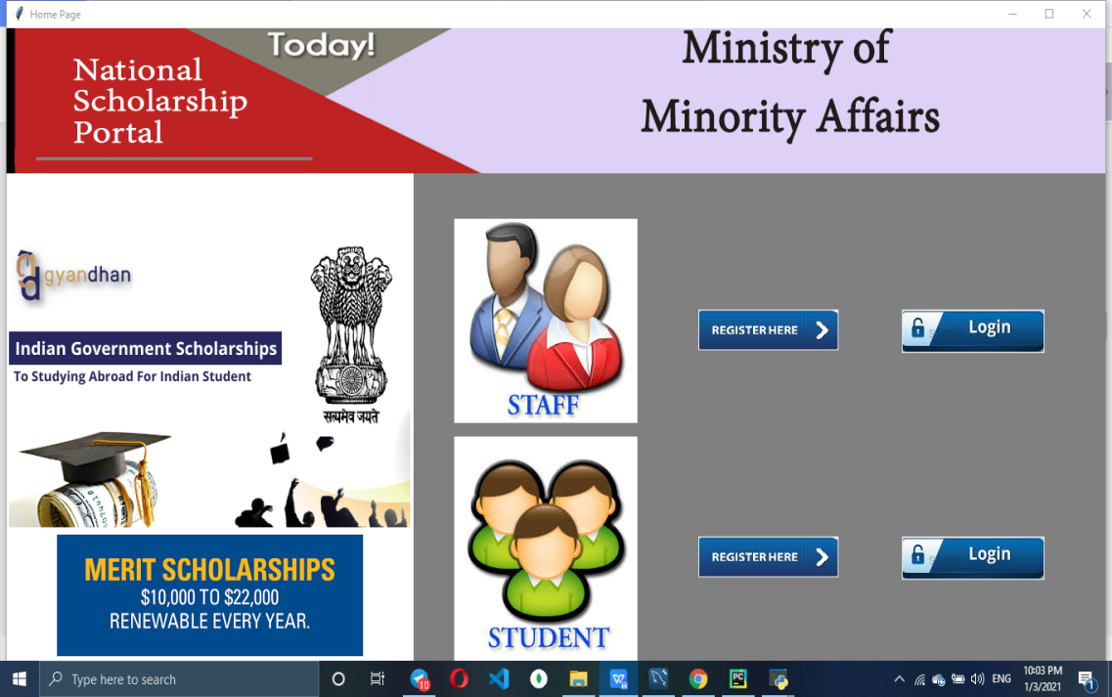

Now click on student side registration.

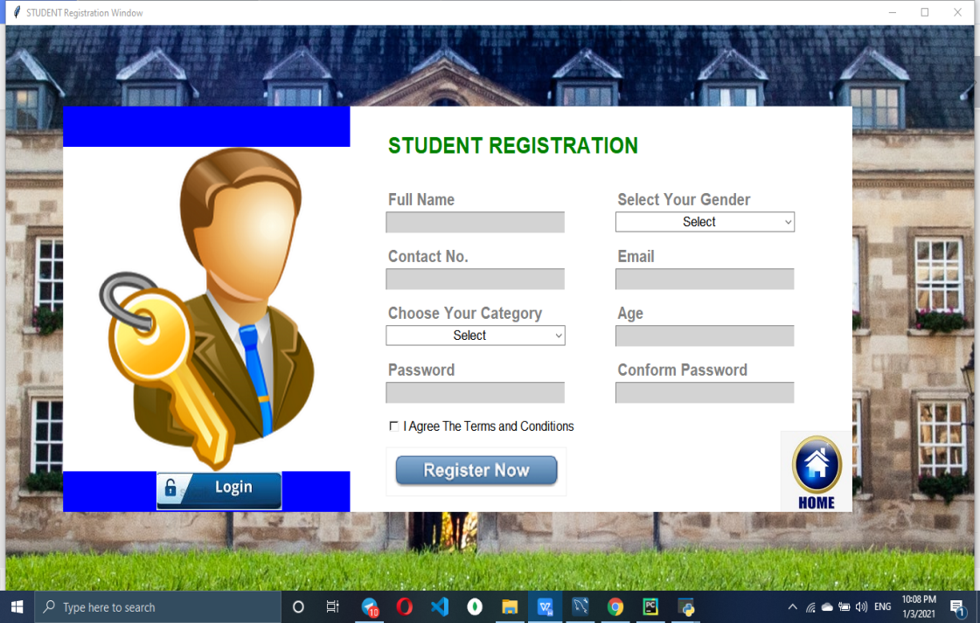

Fill All detail and register. After registration click to home or login button, by both the way we will land on login page.

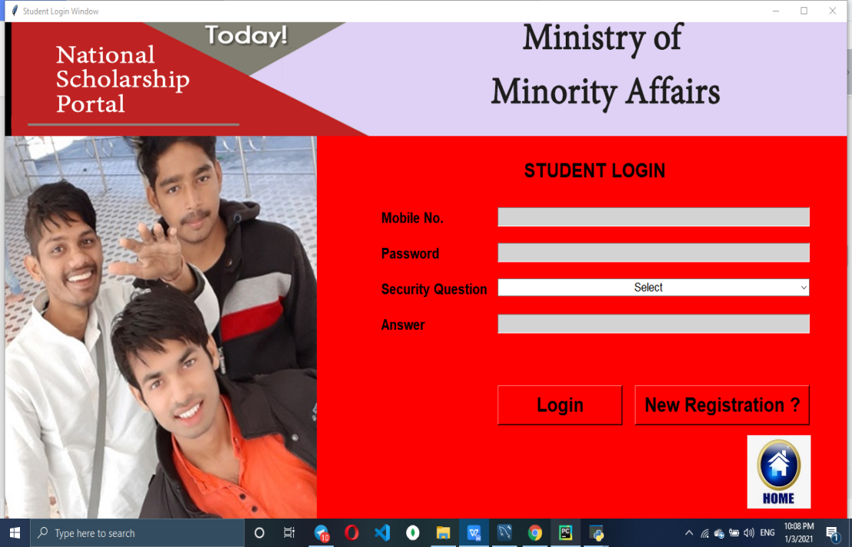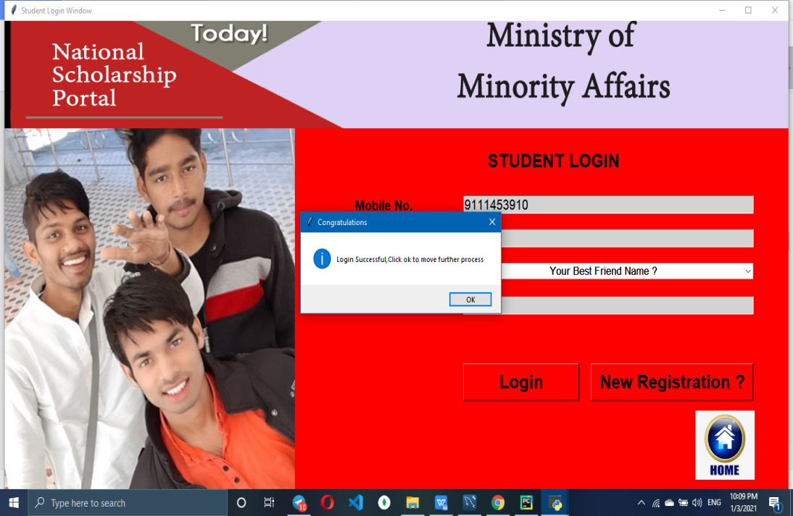

After Login by providing correct username and password. The application form will open. If we will apply by GEN Category or above age 25 then no scholarship will be awarded shown below - 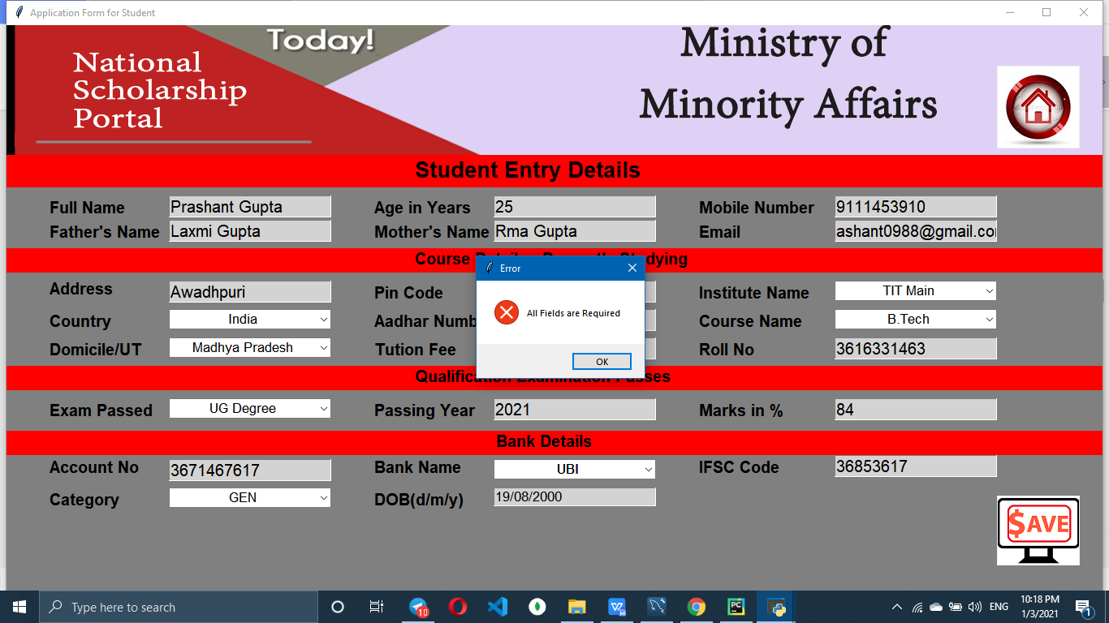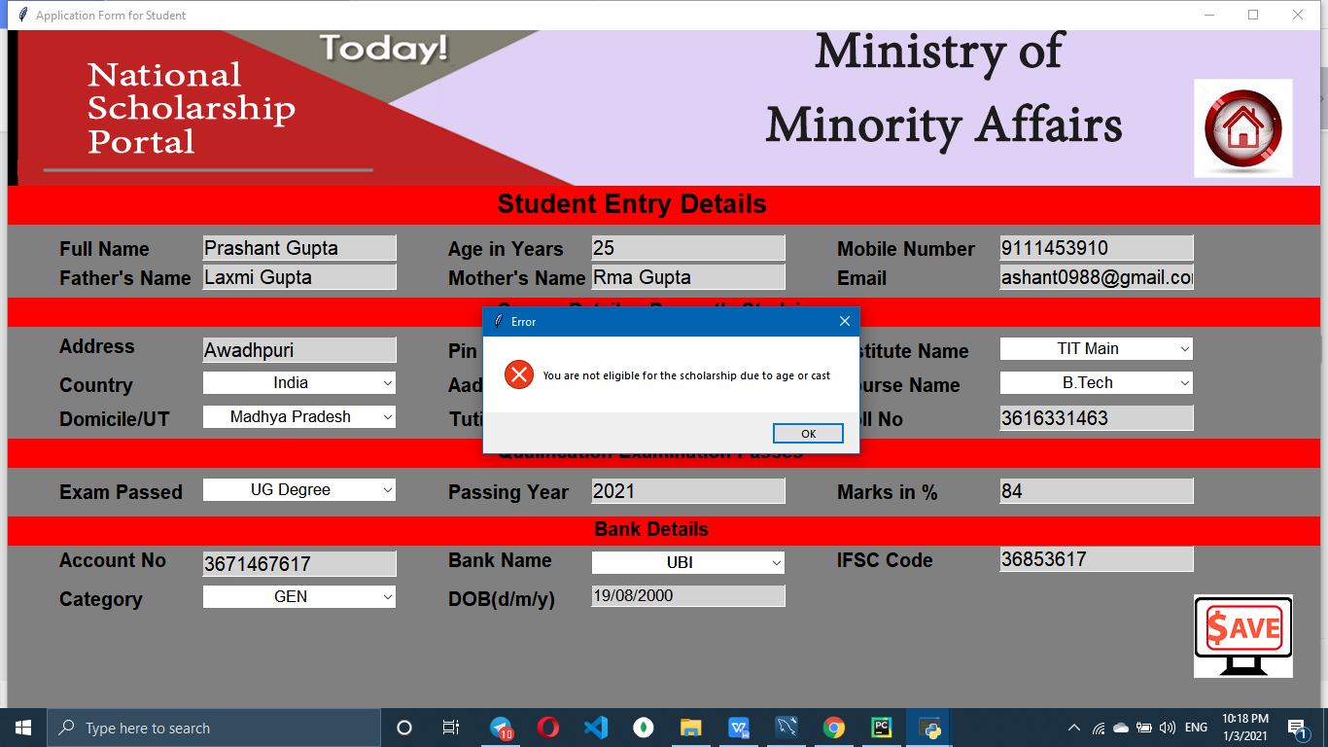

Now fill enter age below 25 and cast other then GEN Then Click Save to prceed further.

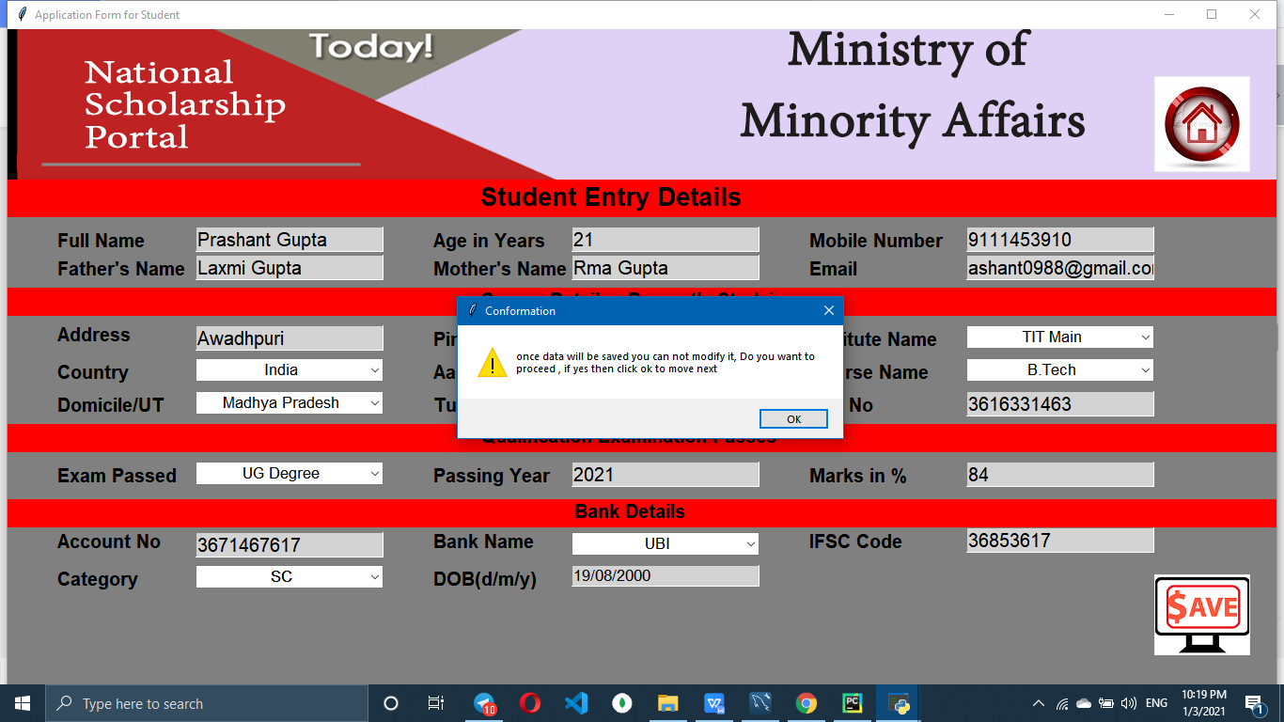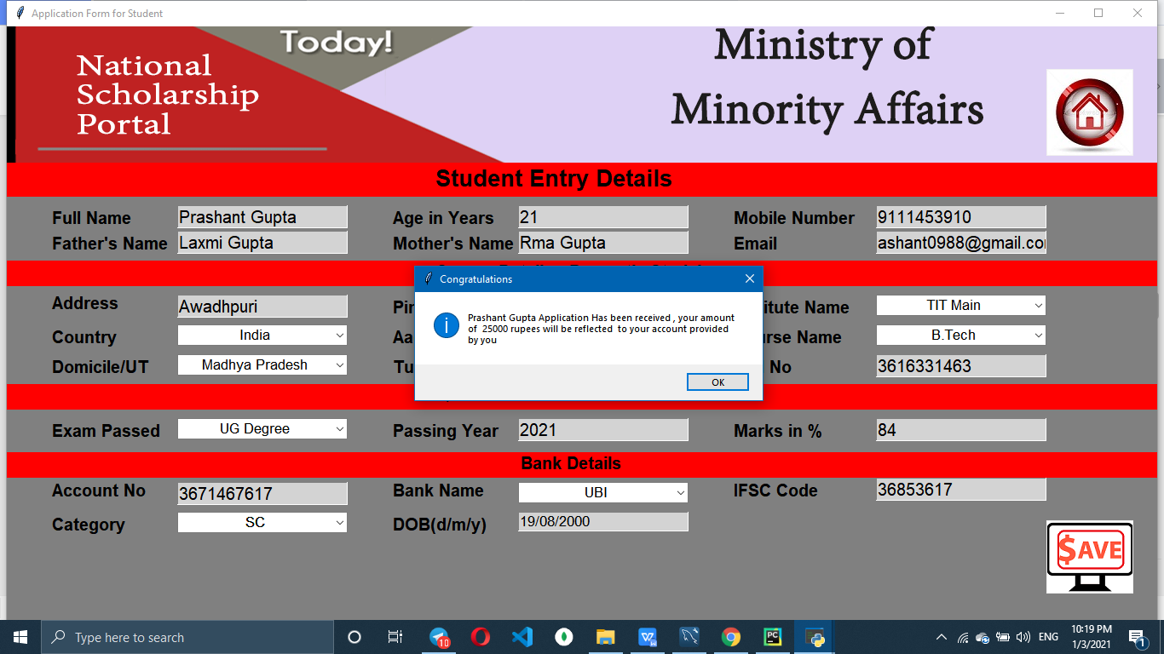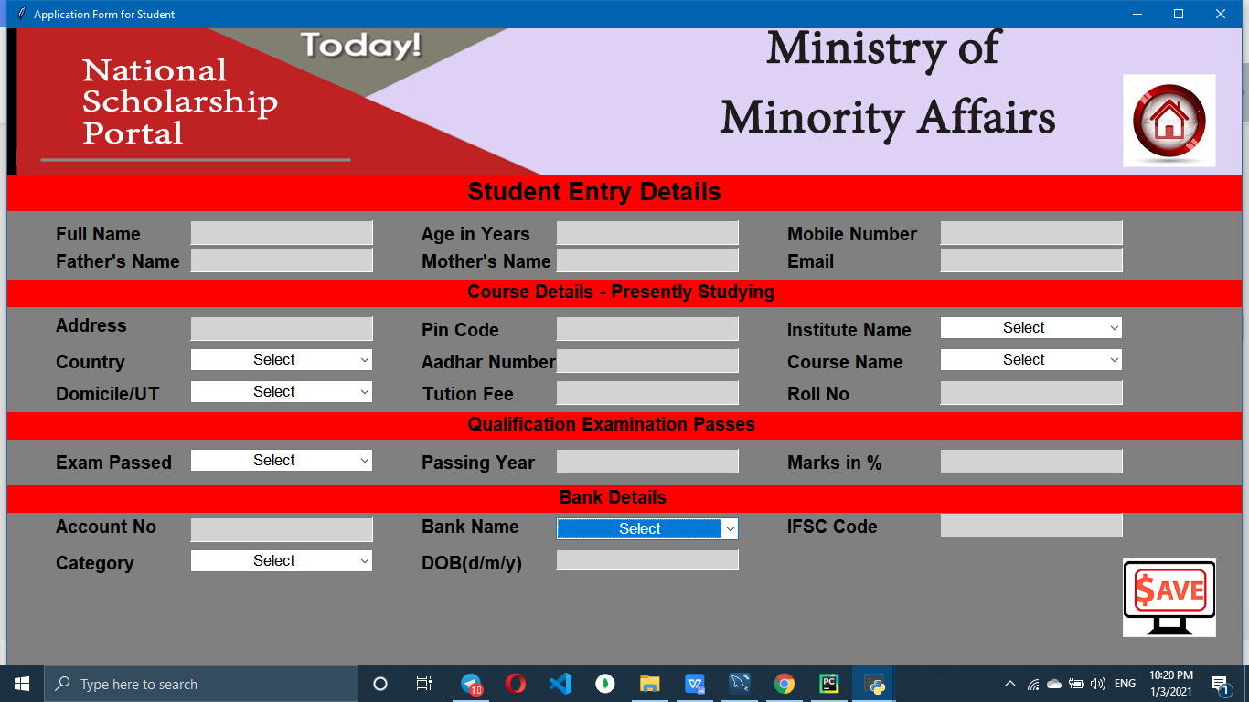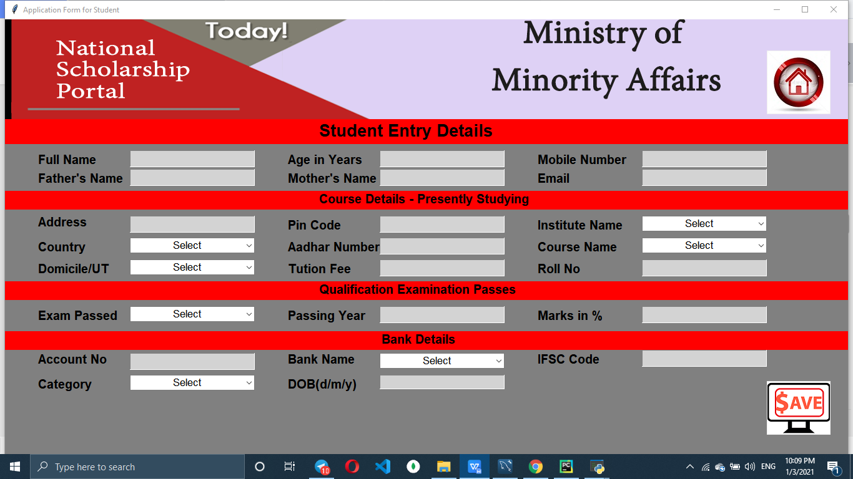

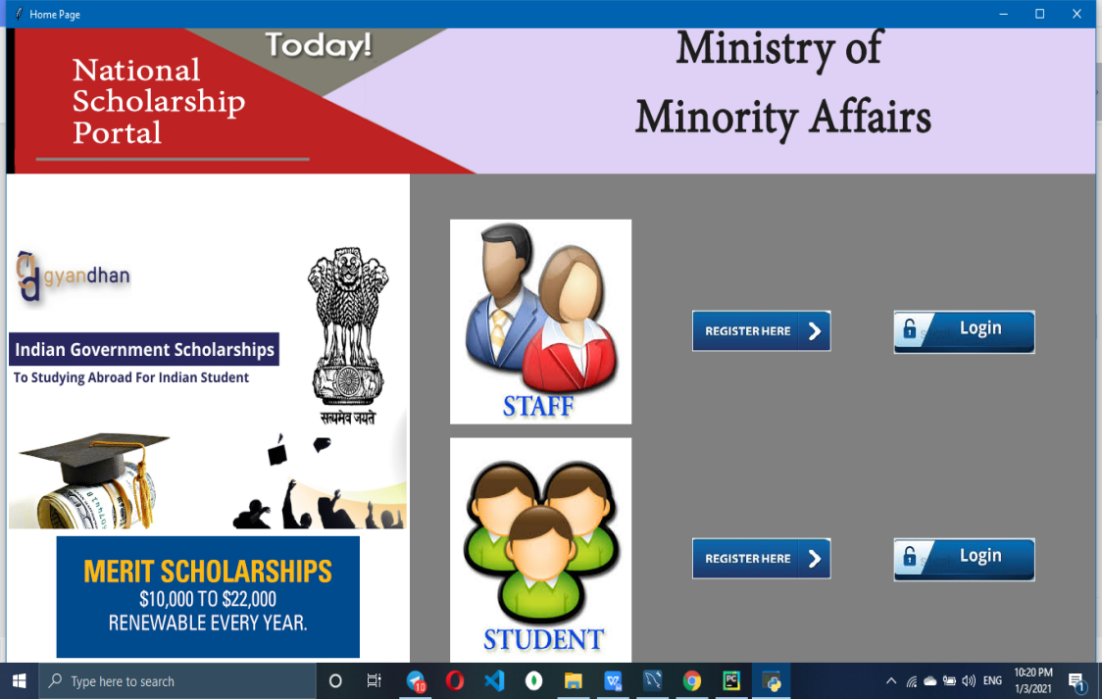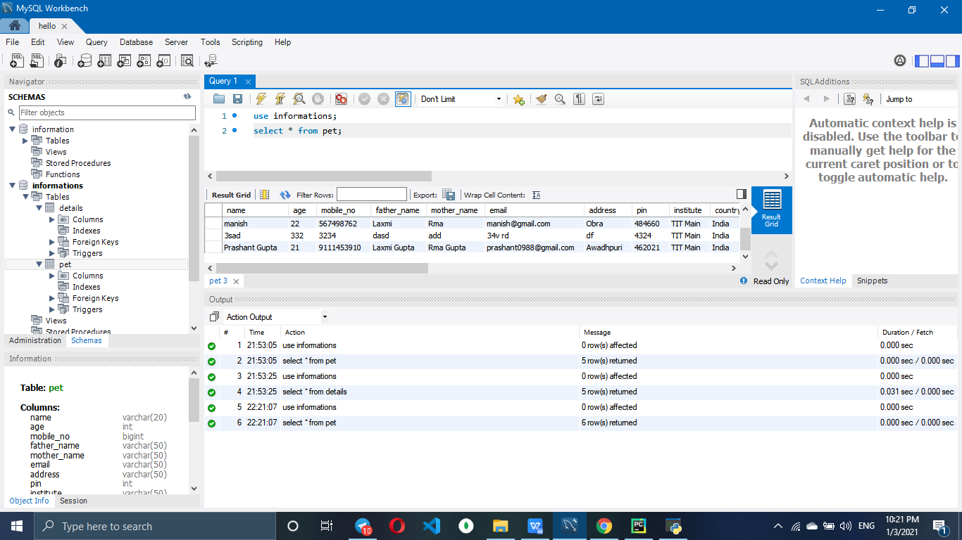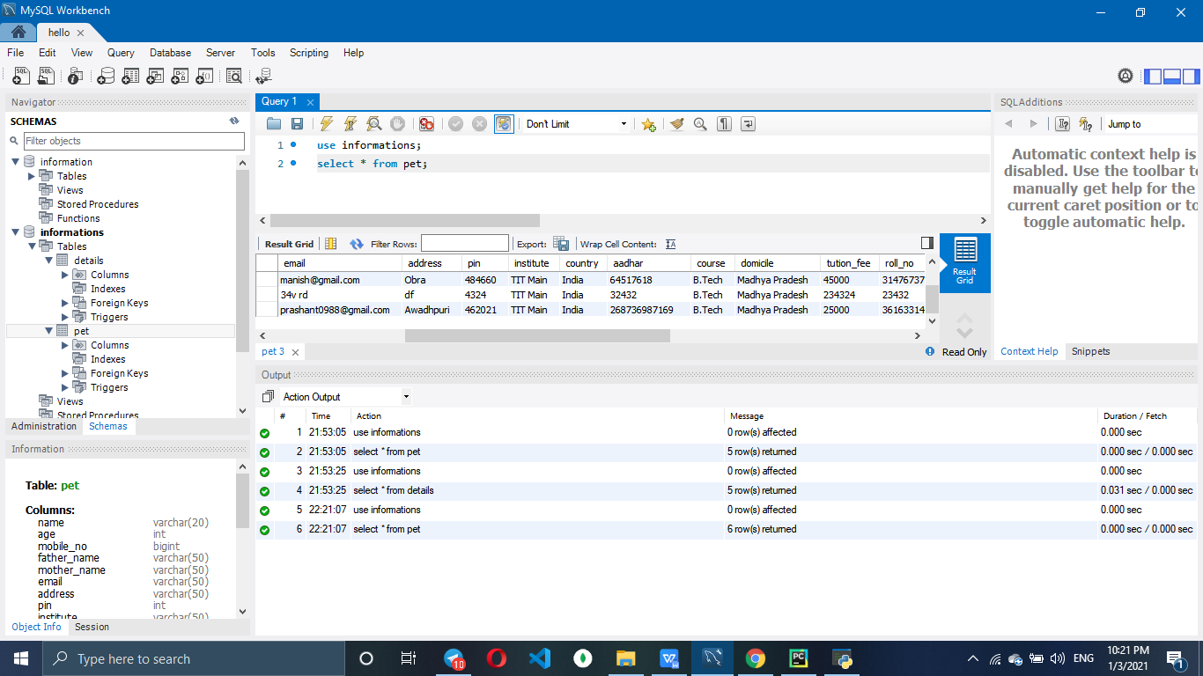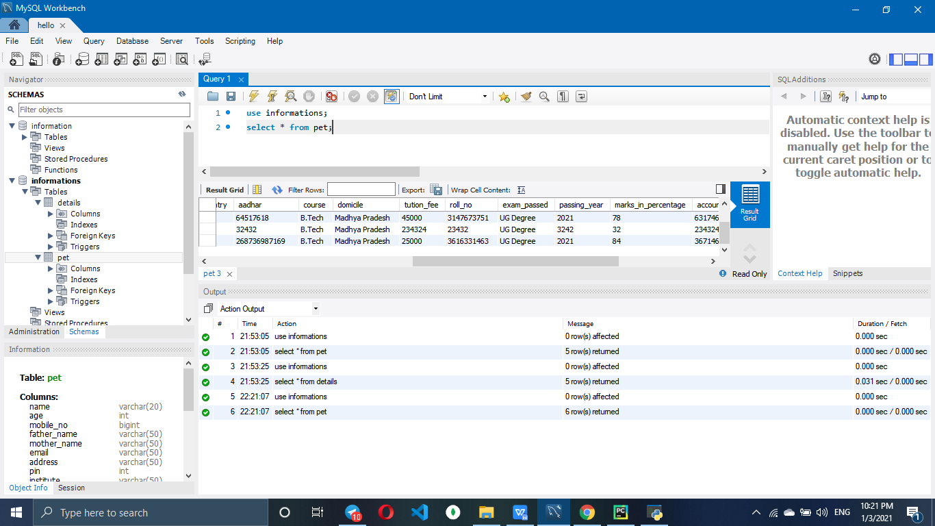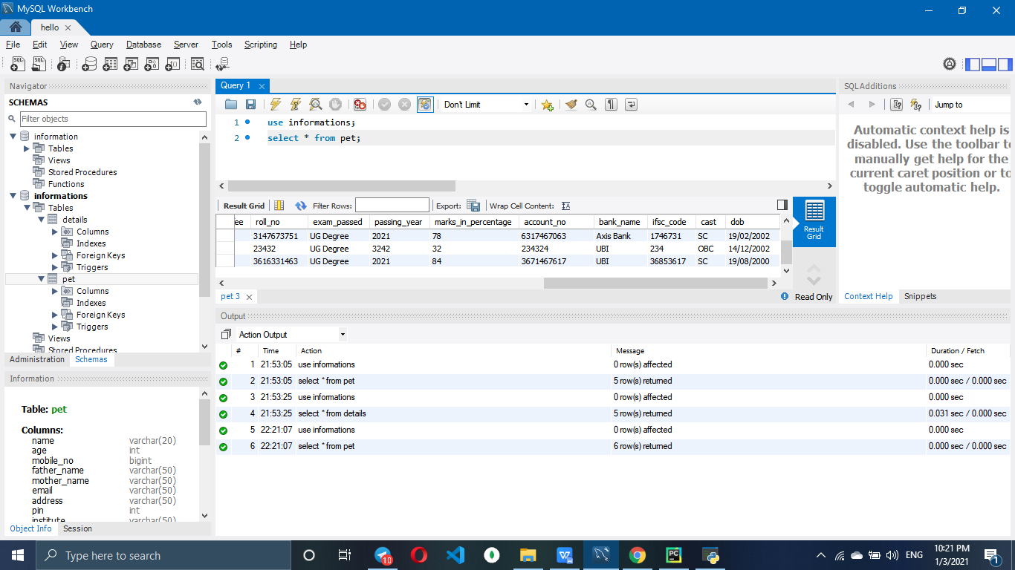

Now data of student application view by staff will look like shown below -

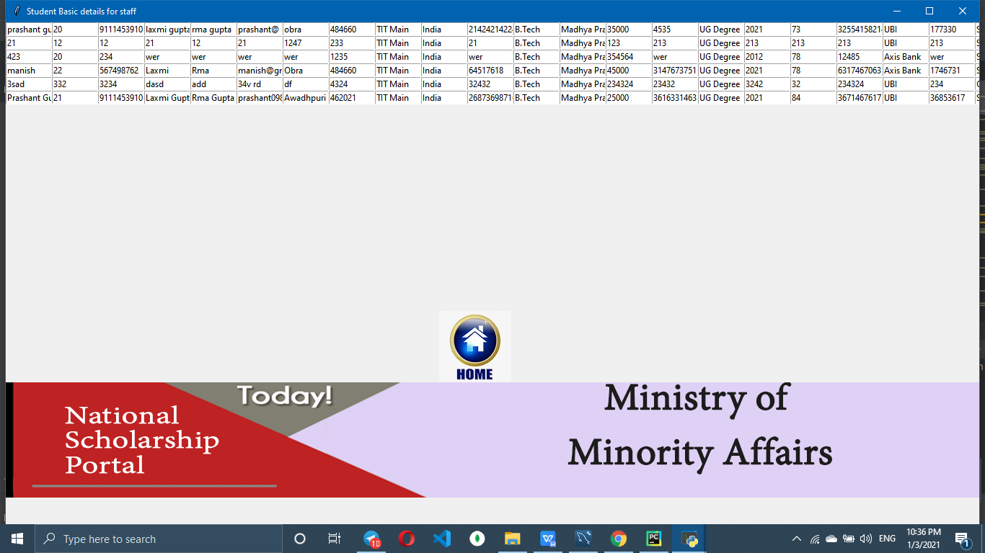

**Conclusion:**

In this project I have created a scholarship poratl including login window & registration for students as well as staffs where anyone can login by providing the username and password. If someone is not having username and password they can click on new registration option and can register. After registration they can use their email id as a username and password provided by them at the time of registration. The data will be stored in database server. Students can register and login after successful login they can apply for the scholarship and staff can see status of all students by login in staff page.

**References and Bibliography:**

1. MySQL Connector(www.w3school.com)
2. Tkinter(www.javatpoint)